MORTAGE CALCULATOR

(present from video: https://youtu.be/eIrMbAQSU34?t=8520)

Long story short, Kay is going to borrow money from bank to buy a property, but he needs to know how much money you need to pay them back, else they take back that property due to no payment on-time. And so Kay come across the mortgage calculator idea, discover the following formula and need your help to make him one:

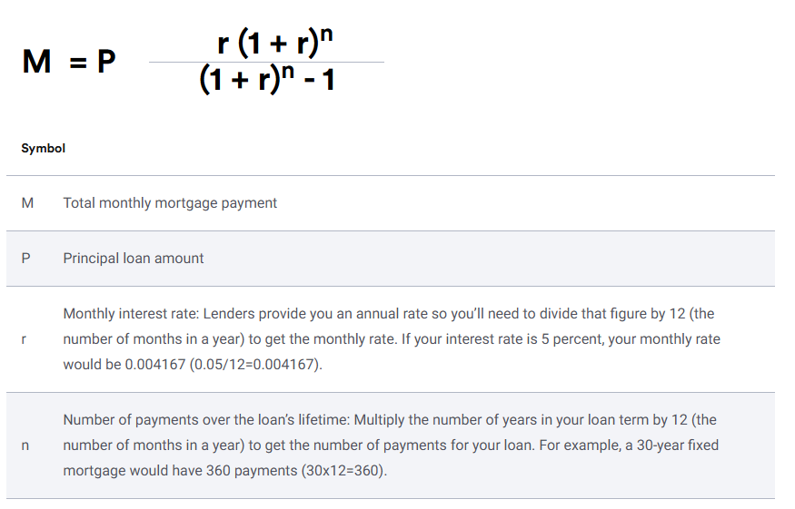

**Task:** construct a program to calculate total monthly mortgage payment for the above problem, considering these factors:

* valid Principal loaning amount (how much Kay want to borrow) is between $1k - $1M  
  🡺 input: int
* Annual interest rate can be UP TO 30%, BUT NOT 0  
  🡺 input: float
* Number of years need to do the payment is from 1 to 30  
  🡺 input: int
* Mortgage payment 🡪 float; round up to 2 decibels

**Acceptable form of program:** Console, Text file input, App

**Test cases:**

*Case 1:*

|  |  |
| --- | --- |
| Principal loaning amount = 1  Other values in user’s favor | Error |

*Case 2:*

|  |  |
| --- | --- |
| Principal loaning amount = 1000000 ($)  Annual interest rate = 3.92 (%)  Number of years of loaning term = 30 (years) | Mortgage: $4728.13 |

*Case 3:*

|  |  |
| --- | --- |
| Principal loaning amount = 1000000 ($)  Annual interest rate = 4.92 (%)  Number of years of loaning term = 30 (years) | Mortgage: $5319.45 |